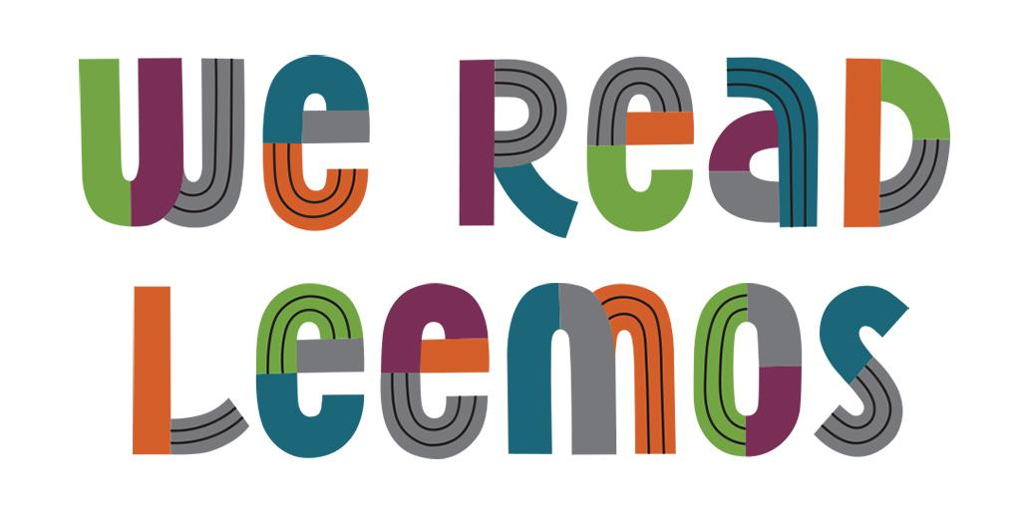

Facebook Posts

- The We Read program is a way for kids, families and adults to celebrate their reading. We’ll share ways We Read and connect you with other readers across the city! Share your favorite things to read or ways to read with the hashtag #WeReadMadison. We’ll feature your photos/videos on our Instagram (@madisonpubliclibrary) page and in our stories! Visit www.madisonpubliclibrary.org/weread to learn more and access downloadable content like posters, an interactive zine and coloring sheets.
- Do you love to read? How, where and what do you read? Share your favorite book or showcase the unique ways in which you read by using hashtag #WeReadMadison on Instagram and tagging @MadisonPublicLibrary. Follow along with the We Read campaign throughout the summer and beyond at www.madisonpubliclibrary.org/weread.

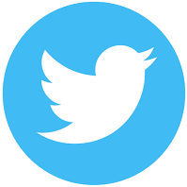

Twitter Posts

- The We Read program is a way for kids, families and adults to celebrate their reading. @MadisonLibrary will share ways We Read and connect you with other readers across the city! Share your favorite things to read or ways to read with the hashtag #WeReadMadison.
- The new #WeReadMadison program from @MadisonLibrary celebrates reading across the city! Visit https://bit.ly/2X1Vea6 to learn more and access downloadable content like posters, an interactive zine and coloring sheets. Follow along on IG @madisonpubliclibrary for inspiration!
- Do you love to read? How, where and what do you read? Share your favorite book or showcase the unique ways in which you read by using hashtag #WeReadMadison on Instagram and tagging @MadisonPublicLibrary.

Instagram Posts

- The We Read program is a way for kids, families and adults to celebrate their reading. We’ll share ways We Read and connect you with other readers across the city! Share your favorite things to read or ways to read with the hashtag #WeReadMadison. We’ll feature your photos/videos on our Instagram page (@madisonpubliclibrary) and in our stories! Visit www.madisonpubliclibrary.org/weread to learn more and access downloadable content like posters, an interactive zine and coloring sheets. #madisonpubliclibrary @madisonpubliclibrary
- Do you love to read? How, where and what do you read? Share your favorite book or showcase the unique ways in which you read by using hashtag #WeReadMadison on Instagram and tagging @MadisonPublicLibrary. Follow along with the We Read campaign throughout the summer and beyond at www.madisonpubliclibrary.org/weread. #madisonpubliclibrary #madisonwi

