Hi [Contact name, organization name],
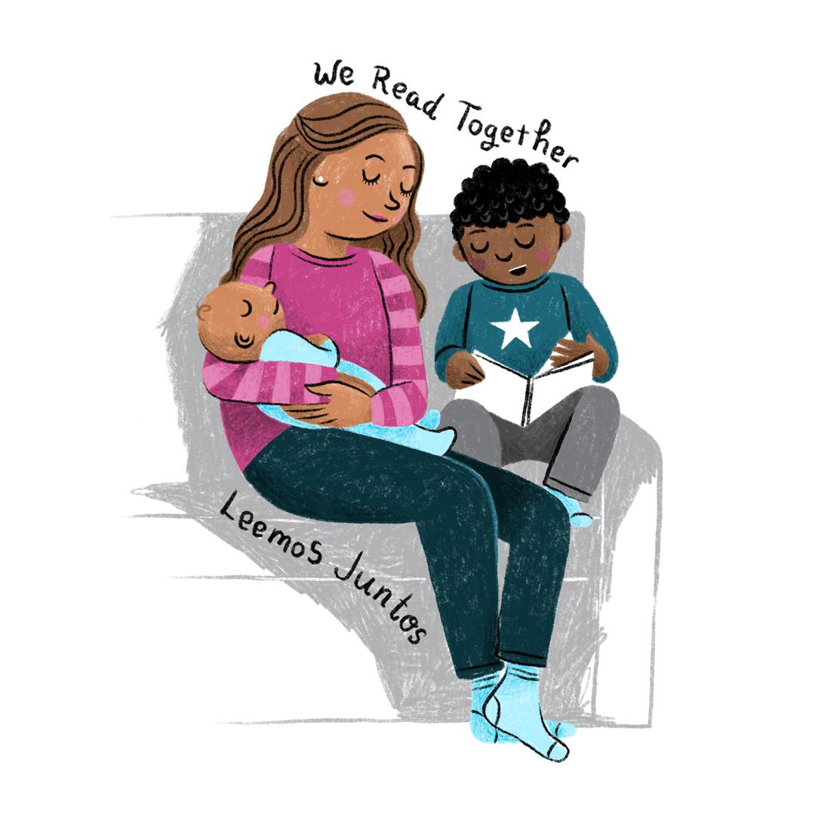
I want to share some changes that are happening with the Madison Public Library’s summer reading program. As of June 8, we’ll be launching a new Madison-wide community celebration of reading - everyone is invited to participate no matter what kind of reading they’re doing! To be a part of We Read, find something to read that you love, share it with a friend or share it on social media and join in the conversation about your favorite ways to read.
“Love it! How can I help?”
So glad you asked! You can:
- Send an email like this one out to [your partners/the parents of your kids].
- Show us how you read by liking/sharing/tagging @MadisonPublicLibrary on Instagram and using the hashtag #WeReadMadison. We’ll be debuting a new We Read theme every 2 weeks.
- Visit the We Read Media Kit for shareable social media graphics, downloadable posters, coloring sheets and an interactive zine.
- Sign up for the Library Kids newsletter where you’ll get updates about We Read.
Visit madisonpubliclibrary.com/weread to learn more about why and how we made changes to the summer reading program or to help us spread the word about We Read.
THANK YOU!
[Your name here]

